Homework

Name：徐政辉 class：17计科全英文 学号：2017329621139

**Question**

**Use the following methods trash() and takeout to answer question (a)-(c).**

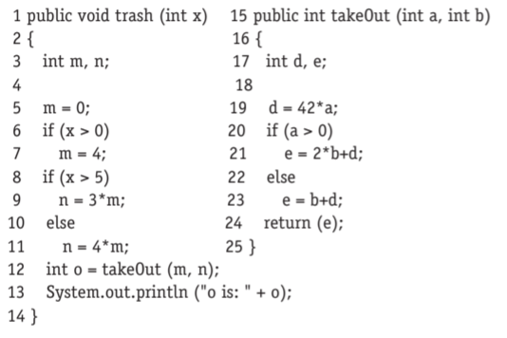

1. **Give all call sites using the line numbers given.**

12

1. **Give all pairs of last-defs and first-uses.**

Pairs = {[5,9], [7,9], [5,11], [7,11]}

1. **Provide test inputs that satisfy all-coupling-uses (note that trash() only has one input).**

Test inputs x = {-1,1,6}